SuperScale

# Team Composition

**CODE BLANK**

Qasim Naveed 21L-5231

Laraib Akhtar 21L-5294

Wajeeh Ahmad 21L-7565

Haseeb Zaheer 21L-5171

# Abstract

Superscale addresses the challenge of upscaling low-resolution images to high resolution through the implementation of advanced artificial intelligence techniques. The document begins with a comprehensive problem statement, outlining the necessity for high-quality image upscaling across various domains such as medical imaging, surveillance, and digital media. The dataset utilized for training and validation purposes is described, encompassing diverse image categories and resolutions to ensure model robustness.

Table of Contents

Team Composition 1

Abstract 2

1. Introduction and Background 4

2. Problem Statement 4

3. Dataset Info 5

4. Preprocessing on Dataset 5

5. Model Information 6

6. Challenges 8

7. Results 9

8. Image Comparison 13

# Introduction and Background

The quest for high-quality image resolution has been a longstanding pursuit in various fields, from medical imaging and satellite photography to consumer electronics and digital media. The ability to upscale low-resolution images to a higher fidelity holds immense value, offering sharper details, improved clarity, and enhanced visual experiences. However, achieving this transformation reliably and efficiently remains a significant challenge, often requiring sophisticated algorithms and computational techniques.

In response to this challenge, the field of artificial intelligence (AI) has emerged as a promising avenue for advancing image upscaling capabilities. Leveraging the power of deep learning, researchers have explored innovative approaches to learn complex mappings from low to high resolution, surpassing traditional interpolation methods. This intersection of AI and image processing has led to the development of state-of-the-art algorithms capable of generating high-resolution images with remarkable realism and detail.

The rise of AI-driven image upscaling techniques, fueled by advancements in computational resources, extensive image datasets, and neural network architectures, contrasts with the limitations of traditional methods like bicubic interpolation. AI models, particularly utilizing CNNs and GANs, excel in capturing high-resolution image details, though challenges remain such as artifact mitigation and computational efficiency. The introduction of Superscale heralds a new era, aiming to tackle these hurdles through innovative approaches and rigorous experimentation, with the goal of delivering cutting-edge solutions for upscaling low-resolution images to high resolution across diverse domains.

**Significance of the Project:**

The rise of AI-driven image upscaling techniques, fueled by advancements in computational resources, extensive image datasets, and neural network architectures, contrasts with the limitations of traditional methods like bicubic interpolation. AI models, particularly utilizing CNNs and GANs, excel in capturing high-resolution image details, though challenges remain such as artifact mitigation and computational efficiency. The introduction of Superscale heralds a new era, aiming to tackle these hurdles through innovative approaches and rigorous experimentation, with the goal of delivering cutting-edge solutions for upscaling low-resolution images to high resolution across diverse domains.

# Problem Statement

The primary reason for upscaling low-resolution images is to enhance their visual quality and usability for various applications. Low-resolution images typically lack detail and clarity, making them less suitable for tasks that require high-definition visuals. By upscaling these images to a higher resolution, essential details are restored, improving their overall quality and making them more suitable for analysis, interpretation, and presentation.

# Dataset Info

For the training and evaluation of the Superscale model, the DIV2K dataset available on Kaggle was utilized as the primary source of image data. The DIV2K dataset is a widely recognized benchmark dataset in the field of image super-resolution, renowned for its high-quality and diverse collection of images.

The dataset comprises a vast array of high-resolution images across various categories, encompassing scenes, objects, textures, and patterns. These images serve as valuable training examples for teaching the model to learn the intricate details and structures inherent in high-resolution imagery.

From the extensive DIV2K dataset, a carefully curated subset of 500 images was selected for training purposes. This subset was chosen to represent a diverse range of content, ensuring that the model learns robust features applicable to different image types and scenarios. Each image in the training set was meticulously preprocessed to optimize its suitability for training, including normalization, augmentation, and noise reduction techniques to enhance model generalization.

In addition to the training set, a separate set of pair of 100 images was reserved for testing and evaluation. These images were held out from the training process to provide an unbiased assessment of the model's performance on unseen data. The images are in pair that is there is high-resolution variant of the image and low resolution variant of image used for training. The test set comprises a mix of images with varying content and characteristics, enabling thorough validation of the model's ability to generalize and produce high-quality upscaled outputs across diverse scenarios.

The utilization of the DIV2K dataset for training and testing ensures that the Superscale model learns from a rich and representative set of high-resolution images, thereby enabling it to effectively upscale low-resolution inputs to high resolution with superior quality and fidelity.

# Preprocessing on Dataset

The preprocessing phase plays a pivotal role in preparing the dataset for training and ensuring optimal performance of the Superscale model. This chapter outlines the various preprocessing steps employed to augment and standardize the dataset before feeding it into the model.

1. **Data Augmentation:** Prior to training, the dataset undergoes augmentation to enrich the diversity of training examples and enhance the model's ability to generalize. Each original image in the training set is augmented by applying random transformations such as rotation, flipping, cropping, and adding Gaussian blur. This augmentation strategy introduces variations in the training data, facilitating robust learning and improving the model's resilience to variations in input images. So in total we have 1000 images dataset for training.
2. **Resizing and Formatting:** Before loading the augmented images onto the training device, they are resized to a standardized dimension of 1500 by 1500 pixels. This resizing ensures uniformity in image sizes, which is essential for batch processing using PyTorch, as tensors within a batch must have the same dimensions. Once resized, the images are formatted and prepared for batch processing.
3. **Batch Processing:** During training, the resized images are organized into batches, with each batch containing 16 images. This batching strategy optimizes computational efficiency and facilitates parallel processing, thereby accelerating the training process. Additionally, within each batch, a high-resolution image and its corresponding low-resolution counterpart are retrieved. The low-resolution image is obtained by resizing the high-resolution image, reducing its height and width by four times.
4. **Further Augmentation for Generalization:** To enhance the model's generalization capabilities, both the high-resolution and low-resolution images undergo additional random transformations before being fed into the model. These transformations include random rotation, cropping, flipping, and other affine transformations. By subjecting the images to diverse variations, the model learns to adapt to different image characteristics and better generalize to unseen data.

By implementing these preprocessing steps, the dataset is effectively augmented, standardized, and optimized for training the Superscale model. This meticulous preprocessing ensures that the model receives diverse and well-prepared training examples, laying the foundation for robust learning and superior performance in upscaling low-resolution images to high resolution.

# Model Information

**Superscale: A GAN-Based Approach:**

Superscale utilizes the framework of Generative Adversarial Networks (GANs), comprising two key components: a generator and a discriminator.

1. **Generator and Discriminator:**
   * The generator in a GAN is responsible for generating data (in this case, high-resolution images) from random noise or input data (low-resolution images). It learns to transform the low-resolution input into high-resolution outputs.
   * The discriminator, on the other hand, acts as a critic. It receives both real high-resolution images and fake high-resolution images generated by the generator. Its task is to distinguish between the two types of images, providing feedback to the generator to improve its performance.
2. **Adversarial Loss:**
   * Adversarial loss is a crucial component of GAN training. It measures the ability of the generator to produce realistic outputs that can fool the discriminator. The loss encourages the generator to generate images that are indistinguishable from real images by penalizing deviations from the discriminator's classification.
   * In Superscale, the adversarial loss is calculated using Binary Cross-Entropy with Logits (BCEWithLogitsLoss), which operates on the logits (raw output) of the discriminator, making it suitable for training binary classifiers like the discriminator in GANs.
3. **ESRGAN Architecture:**
   * Enhanced Super-Resolution Generative Adversarial Network (ESRGAN) is a state-of-the-art architecture for image super-resolution tasks. It builds upon the traditional SRGAN architecture by incorporating residual blocks and residual in residual dense blocks.
   * Residual blocks are fundamental components that facilitate residual learning. They consist of skip connections that bypass one or more layers, allowing the model to learn residual mappings, i.e., the difference between the input and the desired output.
   * Residual in residual dense blocks further enhance the model's representational power by stacking multiple residual blocks within each other, facilitating deeper feature extraction and more effective learning of complex image representations.
   * Kaiming normal weights are used to initialize the model with.
4. **Leaky ReLU Activation:**
   * Leaky Rectified Linear Unit (ReLU) activation functions introduce non-linearity into the network by allowing a small, non-zero gradient when the input is negative. This helps prevent the issue of "dying ReLU," where neurons cease to update their weights during training.
   * In Superscale, leaky ReLU activation functions are used throughout the network to ensure efficient gradient propagation and mitigate the risk of vanishing gradients, particularly in deeper architectures like ESRGAN.
5. **Loss Functions:**
   * Content Loss: Content loss measures the similarity between features extracted from the generator's output and ground truth high-resolution images. It ensures that the generated images preserve essential content and structural information. It uses pretrained model of vgg19 to extract features of the ground truth image and then compare them with the features of image generated by generator and compare how much content was lost.
   * Pixel Loss: Pixel loss, computed using L1 loss, penalizes differences between pixel values in the generated and ground truth images. It encourages the generator to produce visually similar images by minimizing pixel-level discrepancies.
   * Adversarial Loss: As mentioned earlier, adversarial loss encourages the generator to produce images that deceive the discriminator, effectively aligning with the discriminator's classification. It plays a crucial role in enforcing realism and naturalness in the generated images.
   * Each loss is assigned a weight and final loss is calculated by adding these losses multiplied by their weights.
6. **Training Strategy:**
   * Superscale employs the Adam optimizer, a popular choice for training deep neural networks, due to its adaptive learning rate capabilities and computational efficiency.
   * Additionally, a multi-step learning rate scheduler is utilized to adjust the learning rate during training. This technique helps stabilize training, prevent overfitting, and facilitate faster convergence by gradually reducing the learning rate over time.

# Challenges

Training the Superscale model posed several significant challenges, primarily due to resource limitations, complex loss management, and the intricate tuning of hyperparameters.

1. **Limited GPU Resources:**
   * The primary challenge stemmed from the limited computational resources available for training. With only a single GPU equipped with 8GB of VRAM, training the model on a dataset of 1000 images for 250 epochs proved to be computationally intensive and time-consuming.
   * The constrained memory capacity of the GPU necessitated careful optimization of model architecture, batch size, and training parameters to ensure efficient memory utilization and prevent out-of-memory errors.
2. **Complex Loss Management:**
   * Managing the adversarial training process, which involves balancing the losses of both the generator and discriminator, posed a significant challenge. If one loss overshoots or dominates over the other, it can disrupt the training dynamics and hinder the model's learning progress.
   * Achieving a delicate balance between the adversarial loss, content loss, and pixel loss required meticulous fine-tuning of their respective weights and scaling factors. Deviations from the optimal balance could result in suboptimal performance and unstable training behavior.
3. **Hyperparameter Tuning:**
   * Effective hyperparameter tuning proved to be another formidable challenge in training Superscale. Various hyperparameters, including learning rates, batch sizes, optimizer settings, and architectural configurations, needed to be carefully adjusted to achieve optimal performance.
   * Iterative experimentation and manual adjustment of hyperparameters were necessary to strike the right balance between model stability, convergence speed, and output quality. This process often involved extensive trial and error, consuming significant computational resources and time.

# Results

For evaluation following three metrics were used:

* Pixel to Signal Noise Ratio (PSNR)
* Structural Similarity Index (SSIM)
* Mean Square Error (MSE)

Here are the graphs attached for these metrics over 250 epochs.

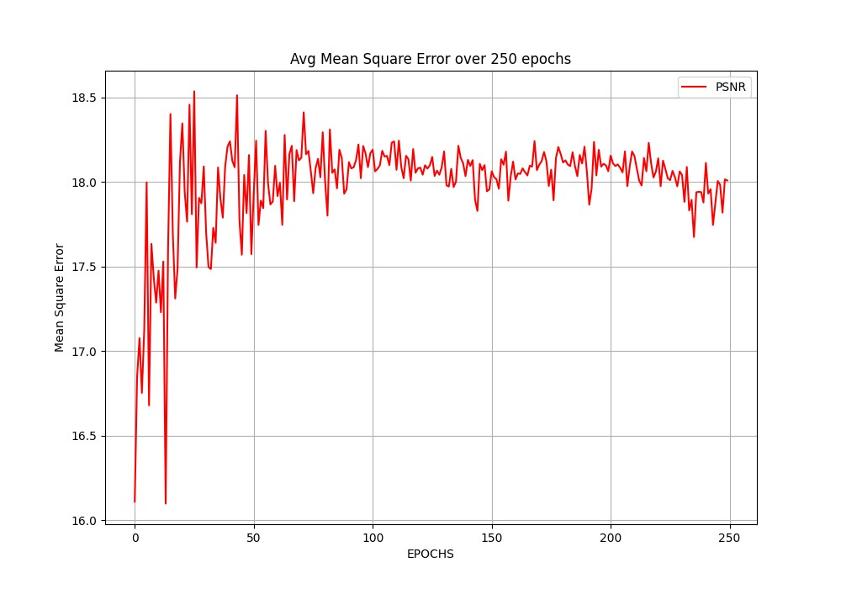

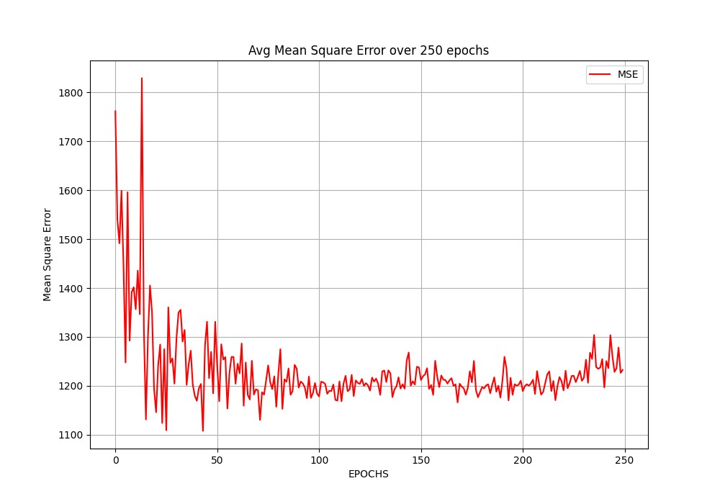

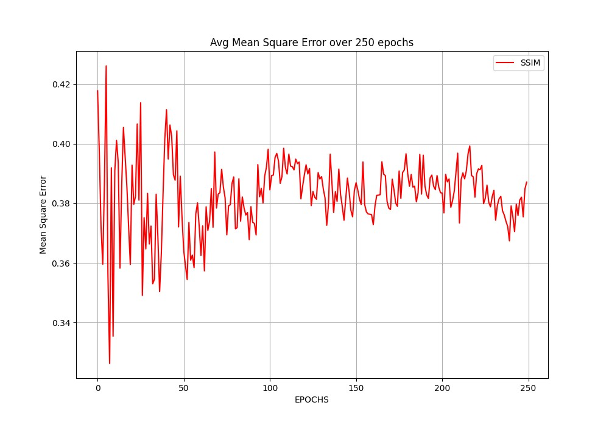

As you can see here MSE and PSNR gradually decreases and increases respectively. But it comes to a halt between 100 and 140 epochs and after that it gradually start to increase and decrease respectively. This is because after that our model starts to overfit the training data and does not perform well on the testing data.  
  
The reason for PSNR not changing overall is that our model short circuits input at various point so it maintains the overall structure of the input image. There is no structural loss or gain because of it.

Now, we will show the generator and discriminator loss and how a balance is achieved between them over 250 epochs so that neither of them overshoots and they continue to learn over the run.

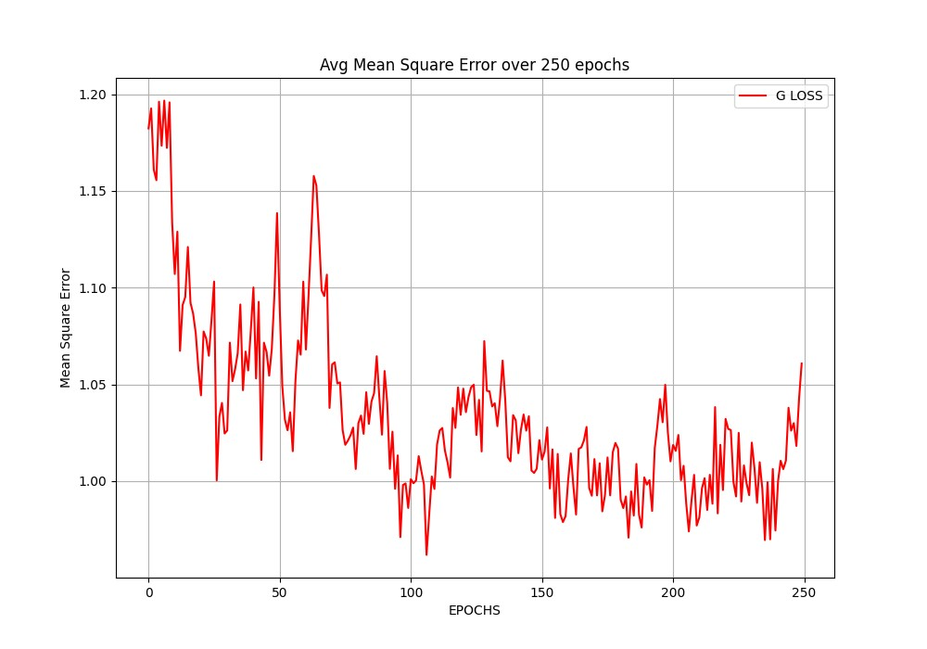

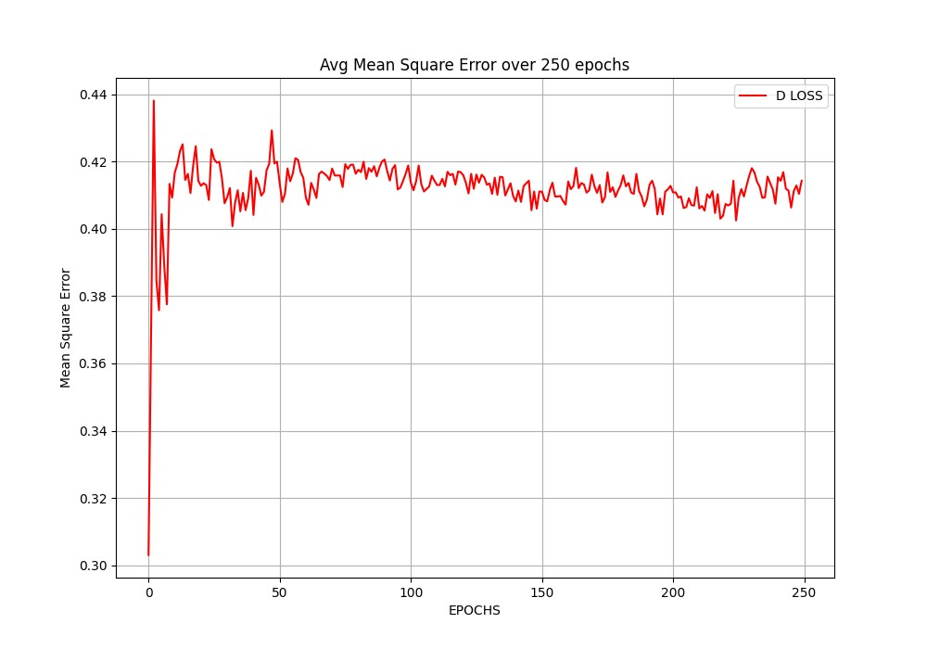

Here you can see here that discriminator remains static over the period this shows that the generator is continuously getting better and it also learns how better generator is getting and adapts accordingly.

# Image Comparison

Now we will show image comparison first the desired image, then pre-trained model of ESRGAN image, then open-cv image and then finally our model’s image.

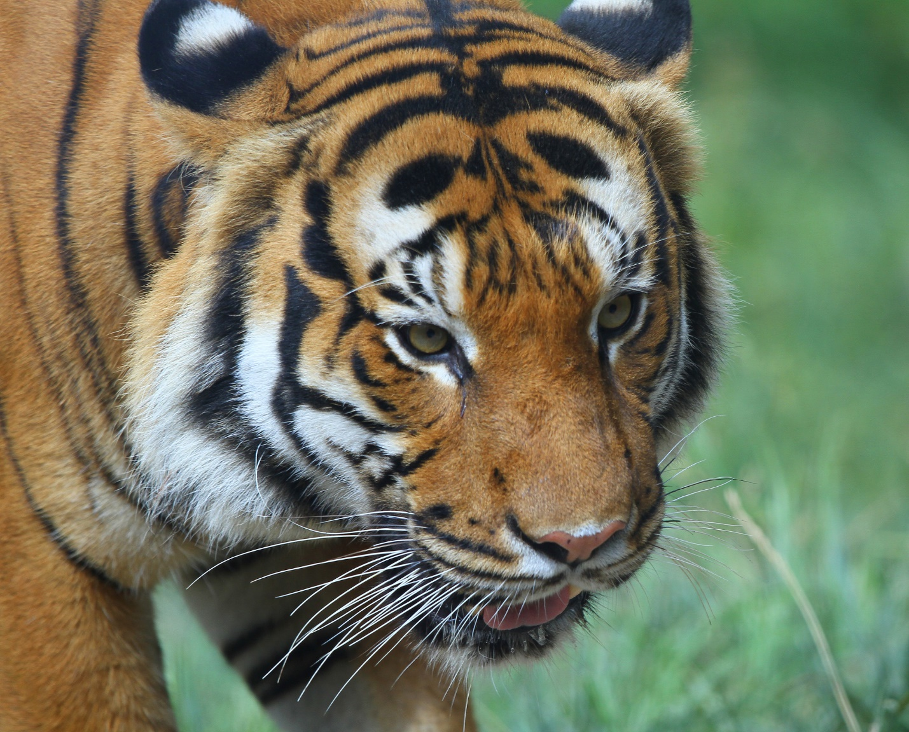  
  
ACTUAL DESIRED OUTPUT  
  
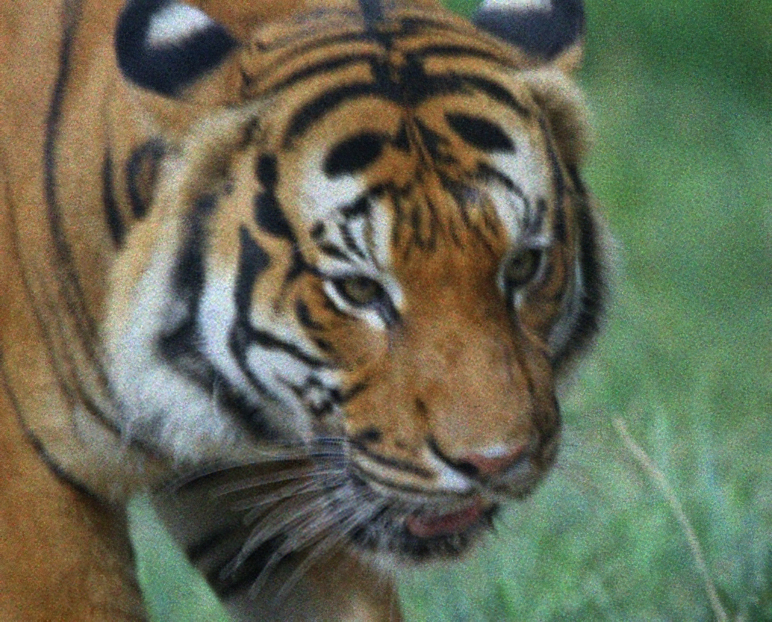  
  
PRE-TRAINED ESRGAN

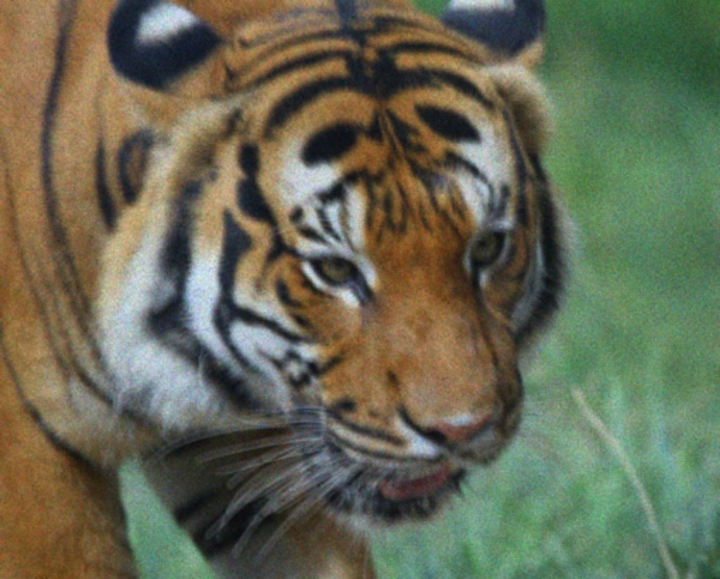  
  
OPEN-CV  
  
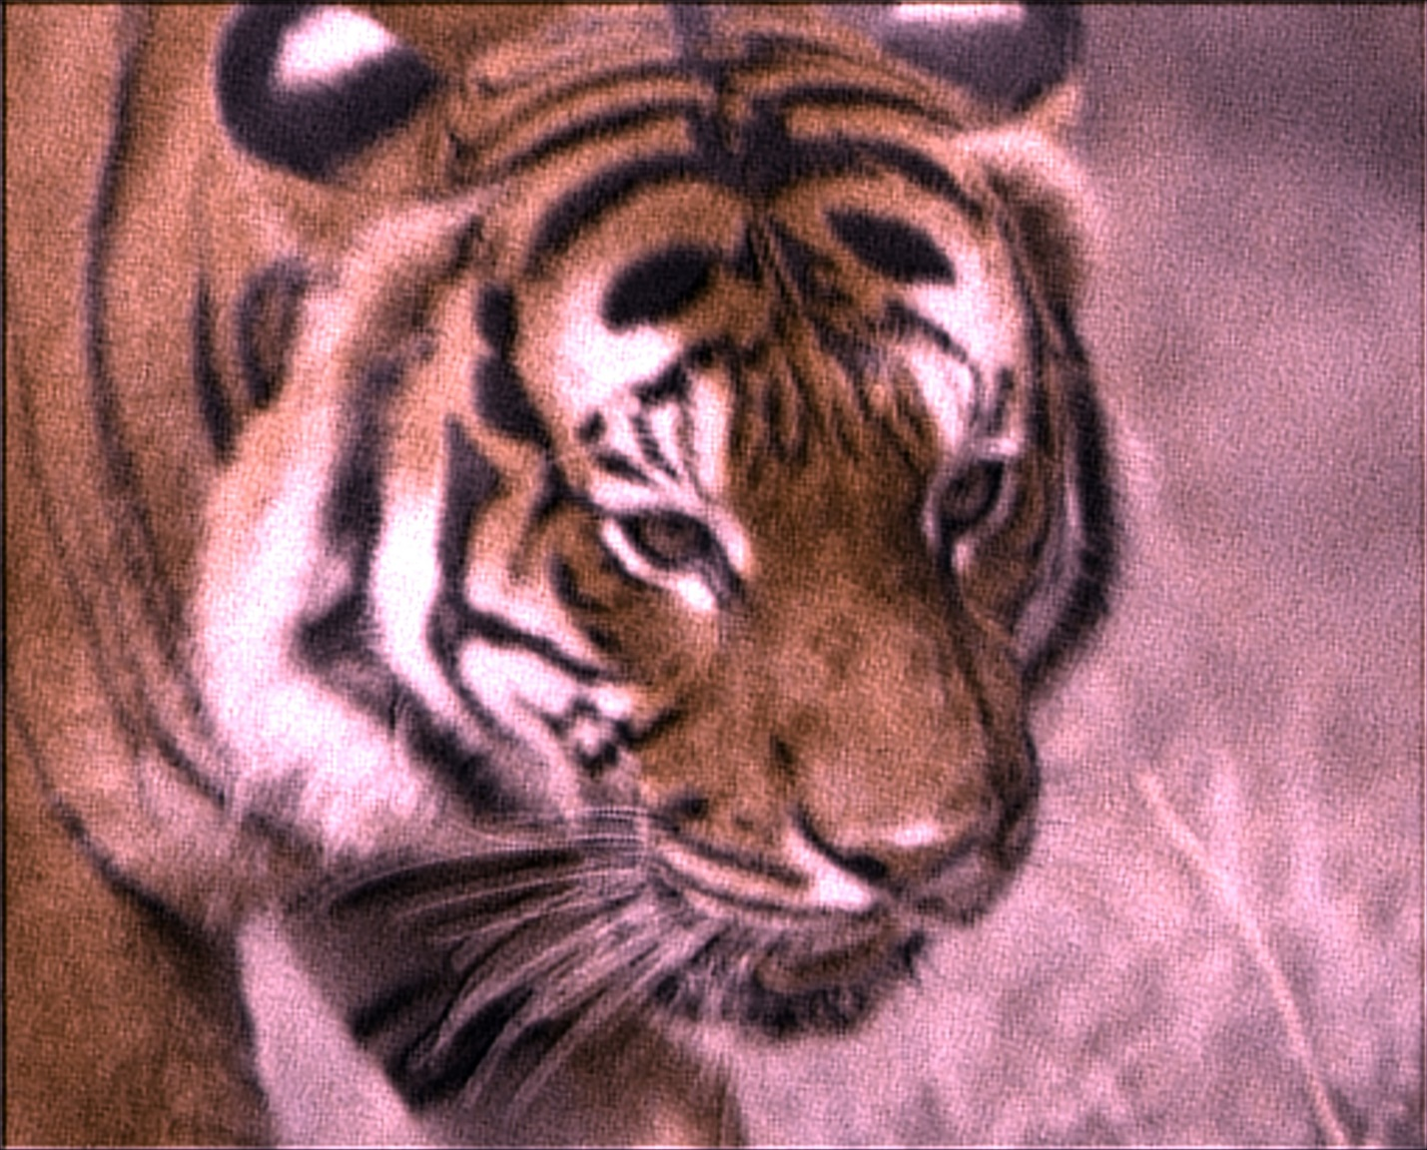  
  
OUR MODEL AT EPOCH 1

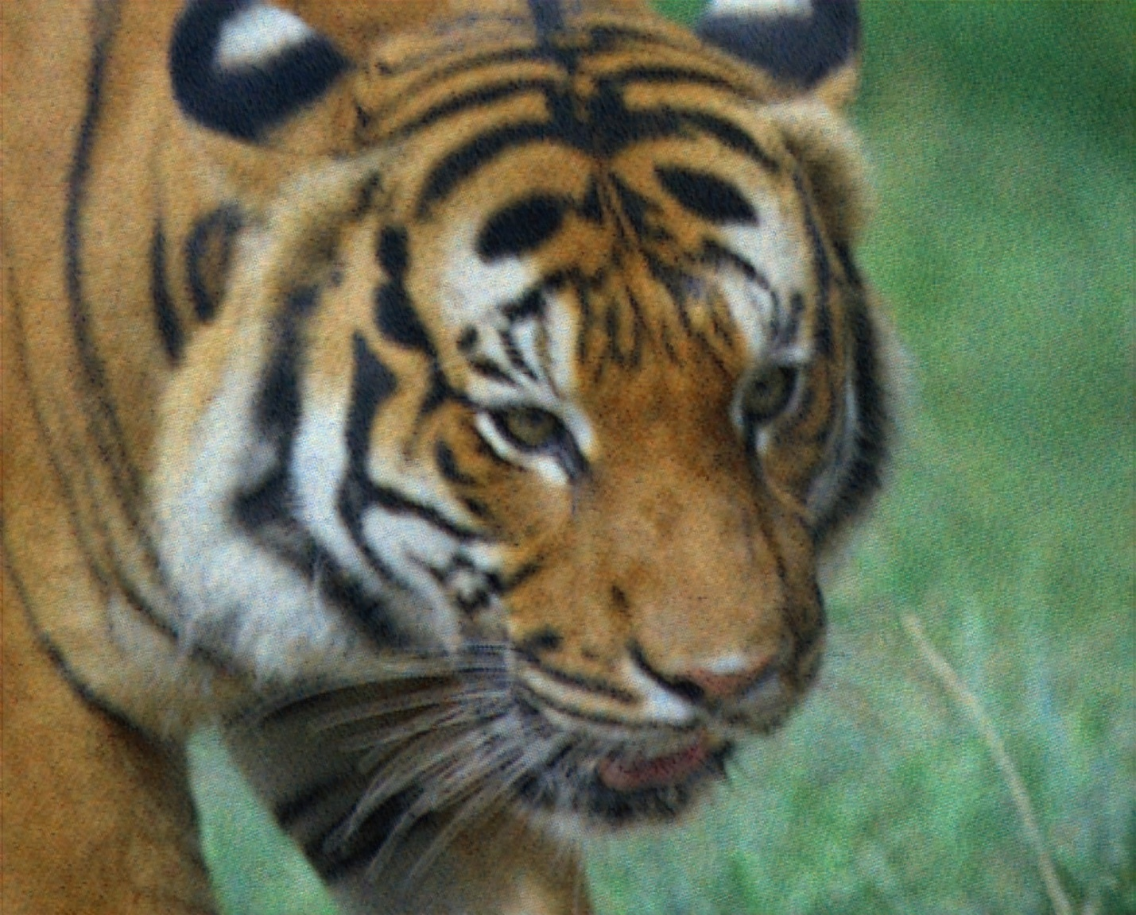

OUR MODEL AT EPOCH 80

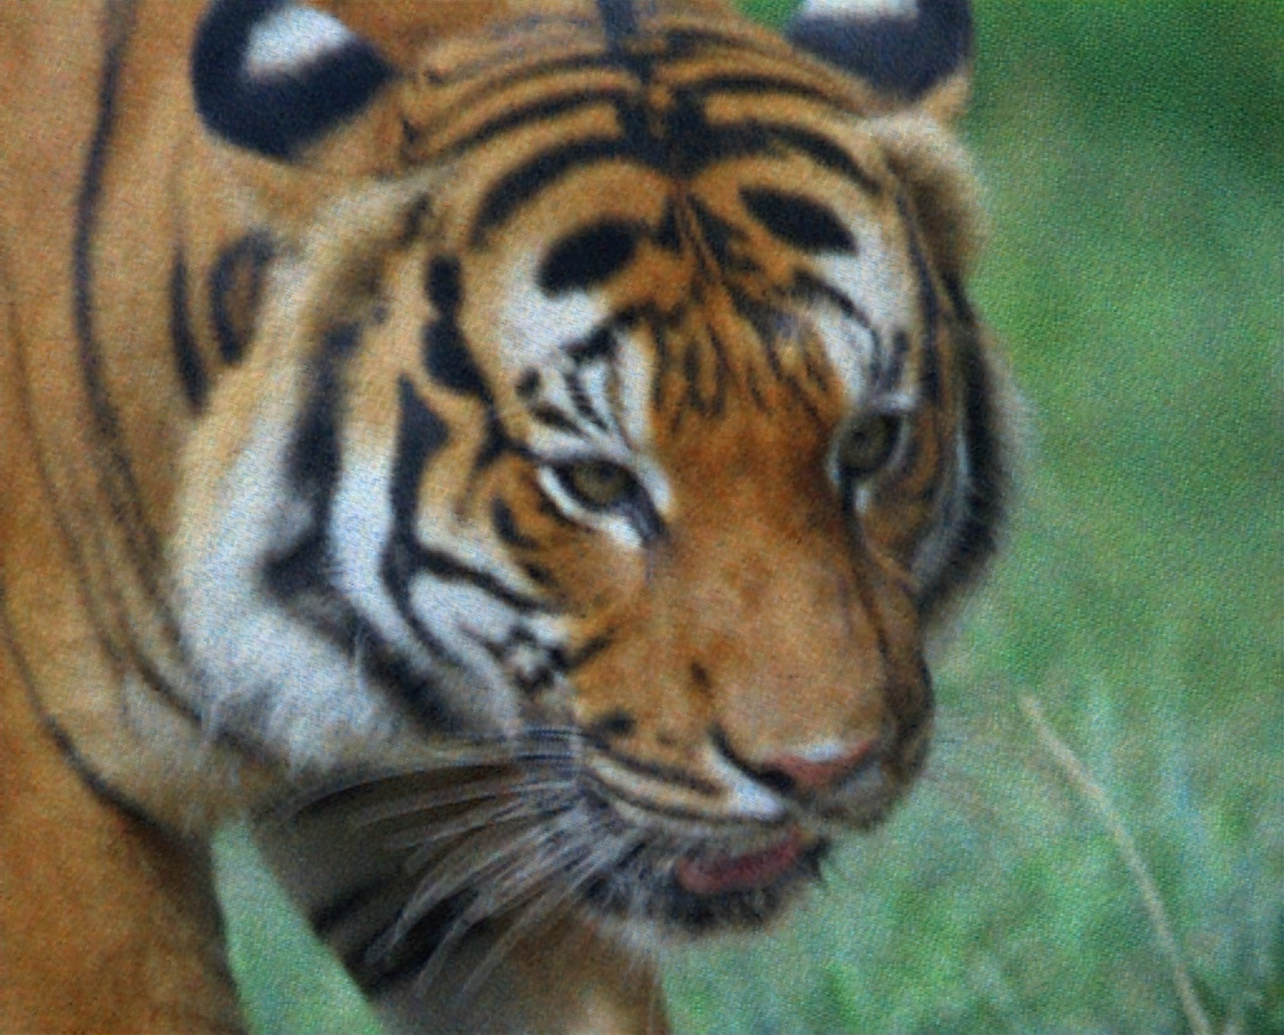

OUR MODEL AT EPOCH 106

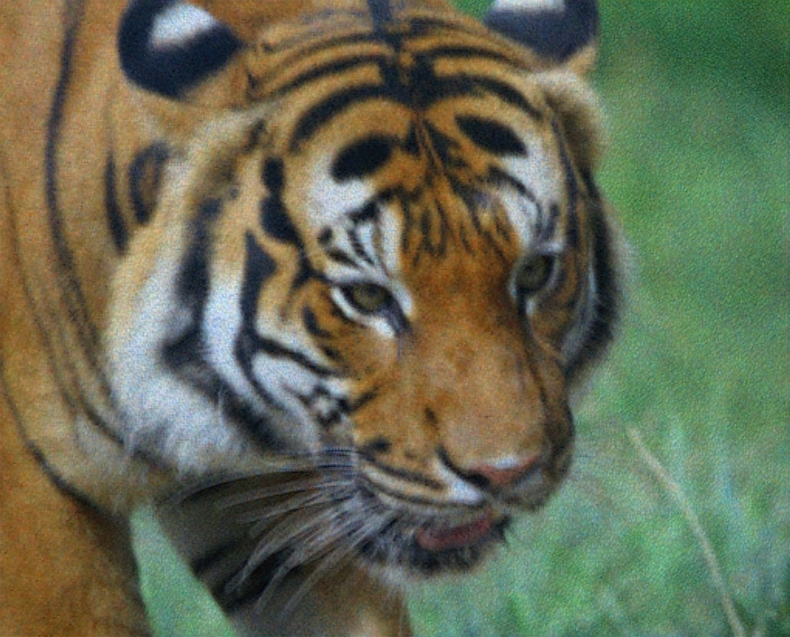

OUR MODEL AT EPOCH 120

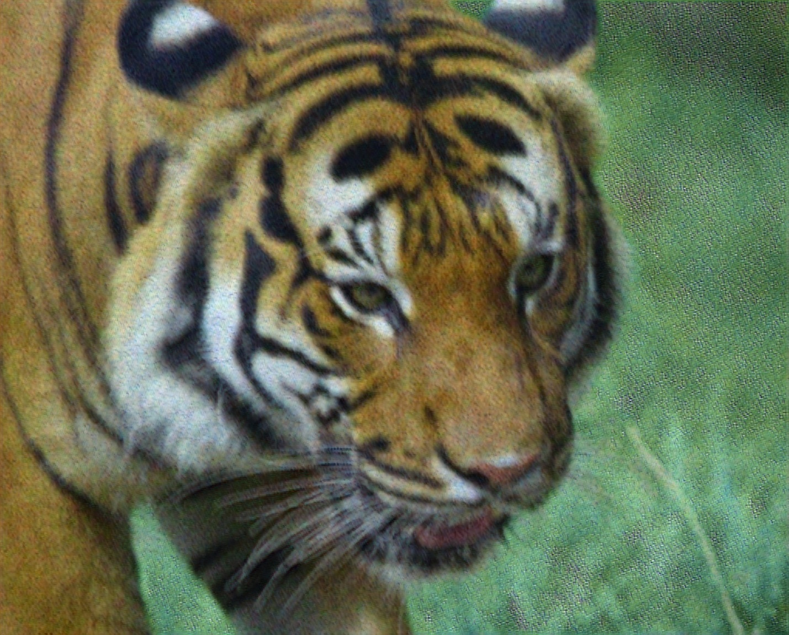

OUR MODEL AT EPOCH 250

# Contribution

21L-5231 Qasim Naveed Model Architecture and Training

21L-5294 Laraib Akhtar Dataset Preprocessing and Graphs

21L-5171 Haseeb Zaheer Testing and Graphs

21L-7565 Wajeeh Ahmad Inference and Server Code